Community Letter to the Albemarle County Board of Supervisors on Woodridge Solar

Dear Albemarle County Board of Supervisors --

Albemarle has an opportunity to lead the way to a clean energy future by bringing more solar to the County. As communities across the globe address the impending climate crisis and advance solutions that slow warming, solar power stands out as a key part of that effort. This petition gives Albemarle residents -and all surrounding community members (including Charlottesville residents)– a chance to make their voices heard on local climate mitigation.
The proposed solar project in the community of Woodridge, in Albemarle County, would generate nearly 400 GWh/year of electricity, enough to power some 30,000 homes, according to C3’s calculations. To better understand the project’s climate justice impacts, C3 applied its newly launched Solar Climate Justice Scorecard, which provides a comprehensive analysis of the following four key climate justice areas: (i) Procedural Justice, (ii) Distributional Justice, (iii) Restorative Justice, and (iv) Other Socio-Economic and Environmental Factors.
Please see C3's full analysis of the project here.
C3 is aware of the potential drawbacks that poorly planned solar projects can pose, which is what prompted us to thoroughly assess the project. We believe this project is the right choice for Albemarle County given the climate mitigation potential of this project as well as the thoughtful attention paid to environmental protection and public engagement.
We urge County Supervisors to grant the solar developer Hexagon Energy a special-use permit to add solar to the Woodridge site to support the project for the benefit of our local community and global climate health.
Project Benefits:
Climate Justice: C3 scored the Woodridge project highly on procedural and distributional justice.
- Community feedback was ultimately included in the project design;
- The harms and benefits are not disproportionately distributed, and existing inequalities are not exacerbated.
Other Socio-Economic and Environmental Factors: The project is expected to reduce carbon emissions and have a net climate change mitigating effect.
- We estimate that in the first year of operations, the clean energy directly created from the project will result in roughly 126,700 US tons of GHG emissions mitigated;
- The strategic location next to existing transmission lines prevents deforestation, and we estimate that for every mile that a new transmission line is prevented, the project could avoid the cutting down of 5,460 to 14,520 trees.

The just clean energy transition not only calls us to reduce our greenhouse gas emissions, but it also gives us the opportunity to increase participation in our energy system. We appreciate the opportunity to address this important issue in our County.
C3 and our fellow, undersigned community members offer our support for the Woodridge solar project and look forward to advancing climate action here at home.
Sincerely,
Albemarle County residents, local community members, and local organizations
March 2023

Partnering Organizations

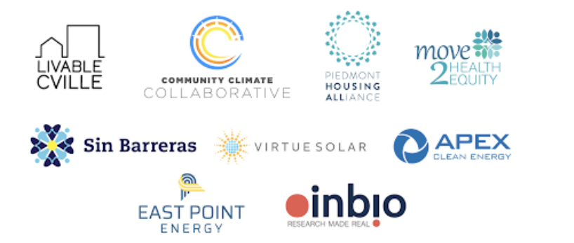

Endorsements From Community Residents

As of March 31^{st,} 2023, this petition was endorsed by 425 community members and included over 100 comments. Of the signatories, over 85% live in Charlottesville or Albemarle County.

Comments of endorsing community members included:
- “Albemarle has an opportunity to lead the way to a clean energy future by bringing more solar to the County. As communities across the globe address the impending climate crisis and advance solutions that slow warming, solar power stands out as a key part of that effort.”
- “As Virginians we need to think about the long-term costs of fossil fuels, not just the immediate costs. Climate change is starting to cost huge amounts for insurance and government. Future cost increases could be exponential as crops fail, forests burn, homes are relocated, power grids and infrastructure must be rebuilt, and water must be shipped to the southwest and West. This project is a small step in the right direction.”
- “I drive an electric car. I would love to have more solar generated electricity available in Albemarle County. The Woodridge project is a good start! Thank you for your attention to the needs of the not-so-far-distant future!”
- “I strongly support solar and other renewable energy developments like this one. In order to achieve a lower carbon footprint, we will need to build new technologies. Building this infrastructure will inevitably have immediate impacts on the environment, but this proposal does everything possible to mitigate negative impacts and to maximize positive ones.”
- “I hope that Albemarle County will be a leader for the Charlottesville Region and work towards building a 100percent renewable energy community. This will help the citizens of Nelson County pursue a similar goal of 100percent renewable energy. It is vital that we establish a green economy as soon as possible because our planet cannot continue on its current path of fossil fuels. Thank you for bringing leadership to our region and working towards a green future.”
- “We just bought our first home in Albemarle County. This is a great opportunity for the County to be a leader in climate action. Further, the project advances the goals of the County's Climate Action Plan. The developers' incorporation of community concerns around local environmental impact is commendable and ensures that the project will bring multiple benefits to the community, beyond clean energy.
- “The need to scale up access to renewable energy couldn’t be more urgent. This project presents a thoughtful and immediate step for our county to make significant progress towards our climate goals. The Hexagon team has gone above and beyond in listening to community needs and incorporating our feedback into their proposal. As the CEO of Virginia’s first net zero winery and the country’s first net zero meadery, I was also thrilled by Hexagon’s invitation to partner with them on restoring their pollinator meadows where we will also place hives to produce local honey as well as a premium honey wine. 50% of the pre-tax profits of our products will also go directly to support biodiversity protection, habitat preservation, and will support the livelihoods of BIPOC, veteran, and women beekeepers...So while this is primarily a solar project, it’s also one that is uniquely positioned to support an entire ecosystem.”
- “As someone who lives across the street from the Albemarle County office building and spends a great deal of time in the county, I hope that Albemarle County will do all in its power to support the growth and economic support in rebates for mid-and low-income consumers to have access to solar energy. Micro-grids if needed. Thank you for listening to your residents and consumers.”
- “I worked for nearly 20 years in the natural gas turbine industry and changed career trajectory earlier this year because I wanted to be a part of the clean energy transition. Excited for the future of PV, BESS, SMRs and other emerging technologies to help us achieve net-zero goals and leave this planet in a better place for future generations. The Woodridge solar project can be a part of it too!”
- “As a fellow developer in the Charlottesville clean energy business community, I write to urge the Albemarle Co. Supervisors to approve the Woodridge Solar project's request for a Special Use Permit. The project is thoughtfully and efficiently sited, the developer has meaningfully engaged with the community and incorporated feedback into the project design, and development of this project will help Albemarle County contribute to its and the Commonwealth's clean energy goals.”
- “I am amazed when I see homes/businesses that would be optimal for solar power not pursue that due to the initial cost. Local, state and federal governments should actively incentivize this which would benefit our community in many ways (financially for struggling families, sustainability and climate mitigation). I love 80- degree days in February but that's just not right.”
- “Planners, board members, and citizens alike would be remiss to not approve this project. As a professional planner, it gives me great satisfaction to endorse such a well-researched, thoughtful, and wholly beneficial project for the County. This project will reduce our dependence on more harmful forms of energy. It also fulfills the highest and best use for the proposed land it occupies. I strongly urge the County to approve this project for the myriad of environmental and economic benefits it will provide.”

